PROJECT

Print on 8x8 matrix Led Using ARDUINO UNO

The 8×8 LED matrix displays are typically used for displaying Short text, counters, symbols etc. They can be daisy chained to form large displays which can be used for the display of scrolling texts, logos among others .

Circuit and Working

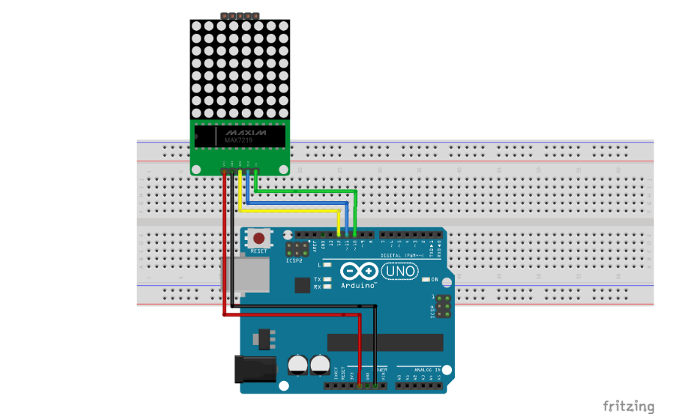

PIN CONNECTIONS

LED Matrix - Arduino

CS - D11

CLK- D10

DIN- D12

GND- GND

VCC - 5V

WORKING

The 8×8 LED matrix is made up of 64 LEDs, graphics, text, and symbols are displayed by turning certain LEDs on while other LEDs are turned off. Instead of writing the byte array to instruct the code on which LED to turn on or off when a particular text or symbol is to be displayed, we can generate the byte array with the help of a simple software called pixeltomatrix. It generates byte arrays for LED matrix after the design has been done to show which LED will stay on and Which LED will go off to properly represent the Image, symbol, or text.

CODE

#include <LedControl.h>

int DIN = 12;

int CS = 11;

int CLK = 10;

LedControl lc=LedControl(DIN,CLK,CS,0);

void setup(){

lc.shutdown(0,false); //The MAX72XX is in power-saving mode on startup

lc.setIntensity(0,15); // Set the brightness to maximum value

lc.clearDisplay(0); // and clear the display

}

void loop(){

byte smile[8]= {0x3C,0x42,0xA5,0x81,0xA5,0x99,0x42,0x3C};

byte neutral[8]= {0x3C,0x42,0xA5,0x81,0xBD,0x81,0x42,0x3C};

byte frown[8]= {0x3C,0x42,0xA5,0x81,0x99,0xA5,0x42,0x3C};

printByte(smile);

delay(10000);

printByte(neutral);

delay(1000);

printByte(frown);

delay(1000);

lc.clearDisplay(0);

delay(1000);

}

void printByte(byte character [])

{

int i = 0;

for(i=0;i<8;i++)

{

lc.setRow(0,i,character[i]);

}

}

